SQL Project

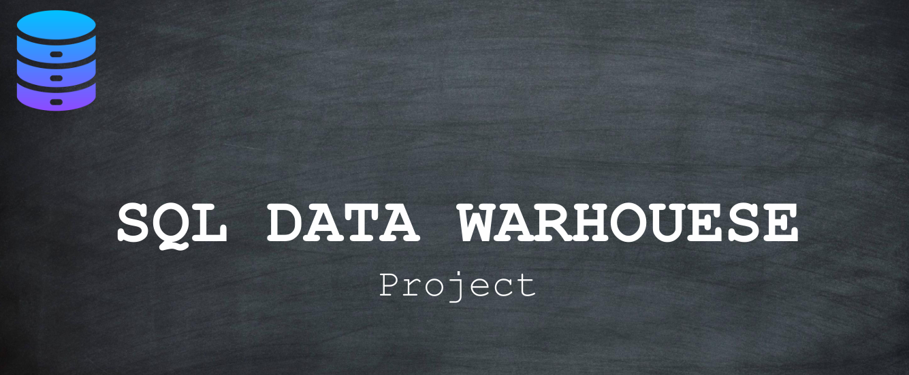

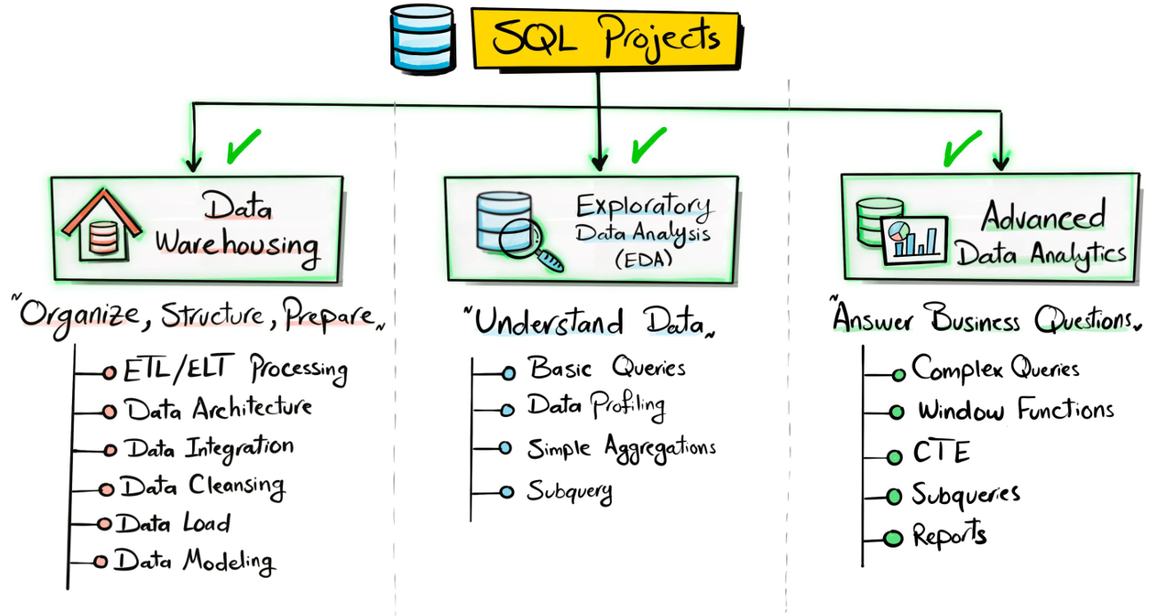

What is a data warehouse ?

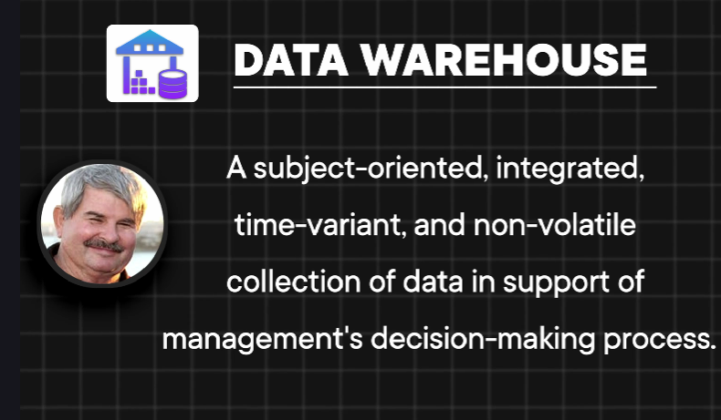

Subject oriented.
It means data warehouse is always focused on a business area like the sales, customers, finance and so on.
Integrated
because it goes and integrates multiple source systems.
Usually you build a warehouse not only for one source, but for multiple sources.
Time variance
It means you can keep historical data inside the data warehouse
non-volatile
It means once the data enter the data warehouse, it is not deleted or modified.
So this is how Bill Inmon defined a data warehouse.

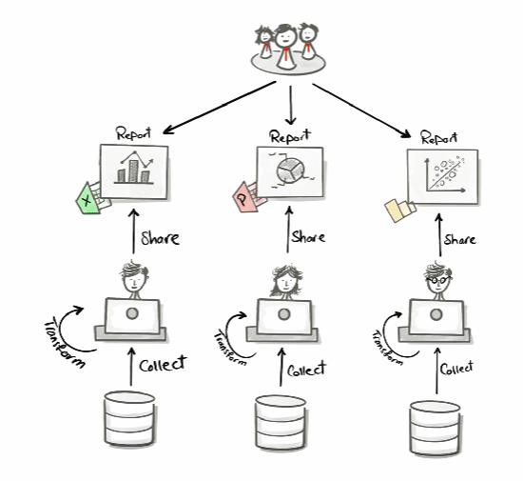

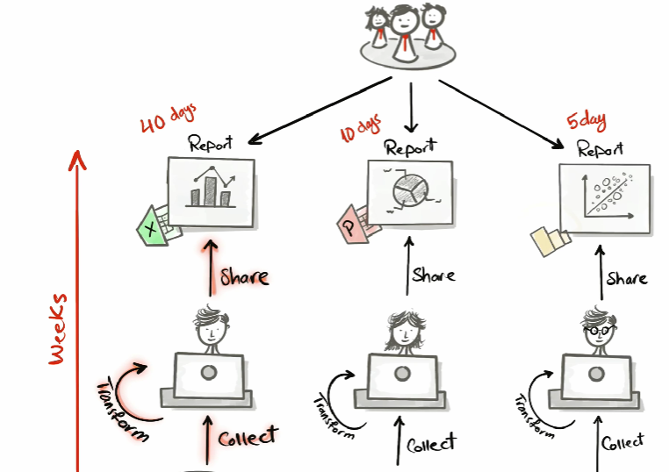

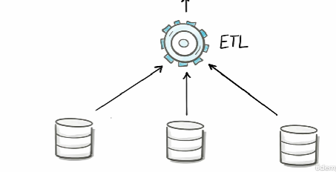

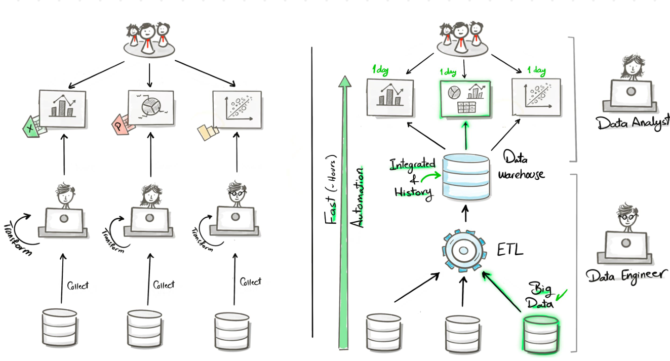

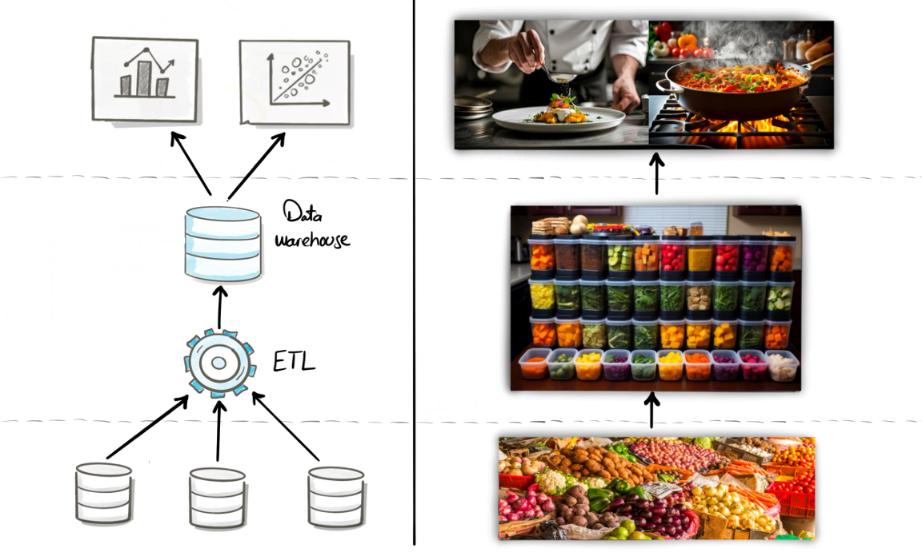

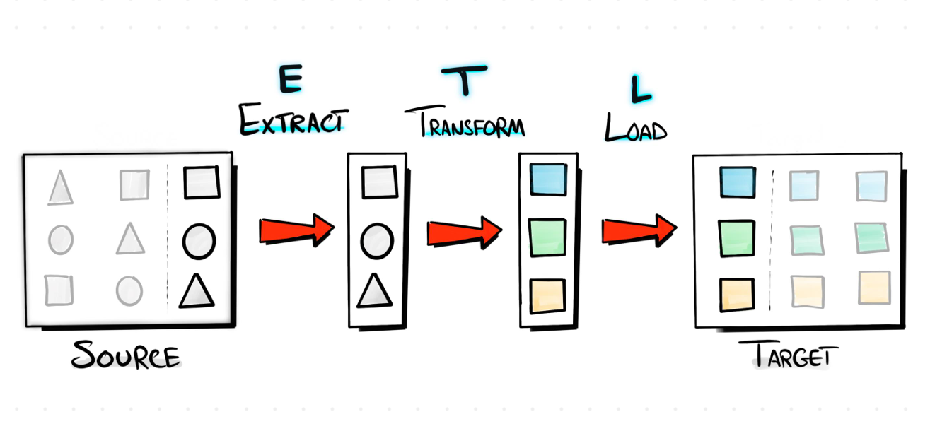

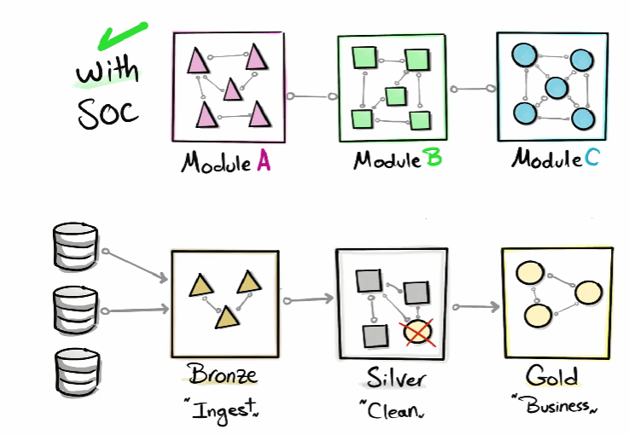

Data Architecture

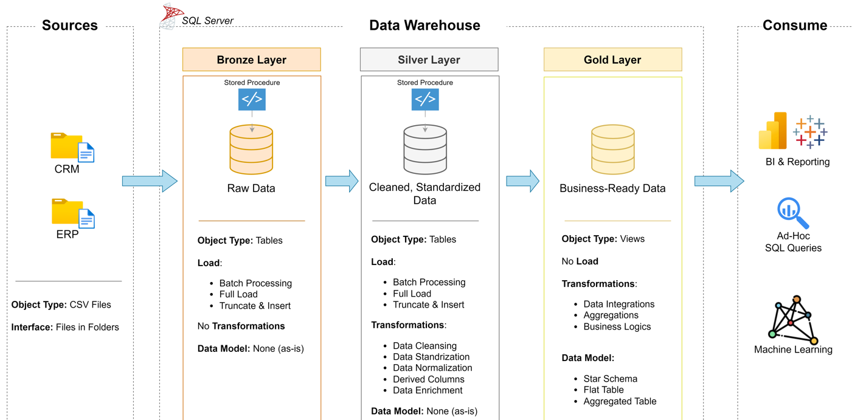

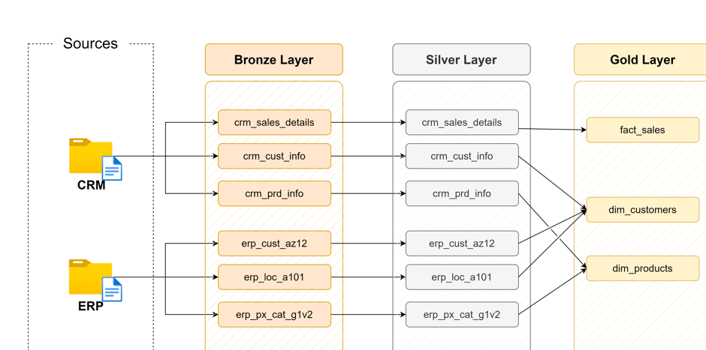

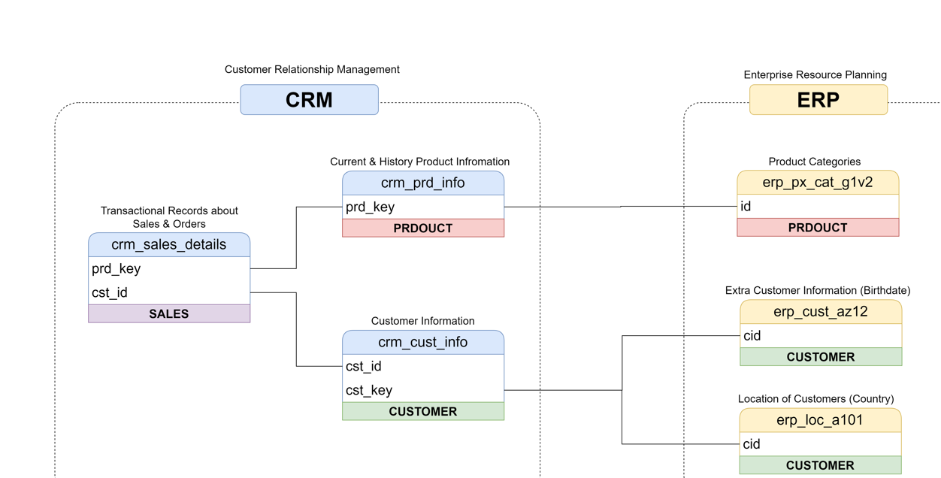

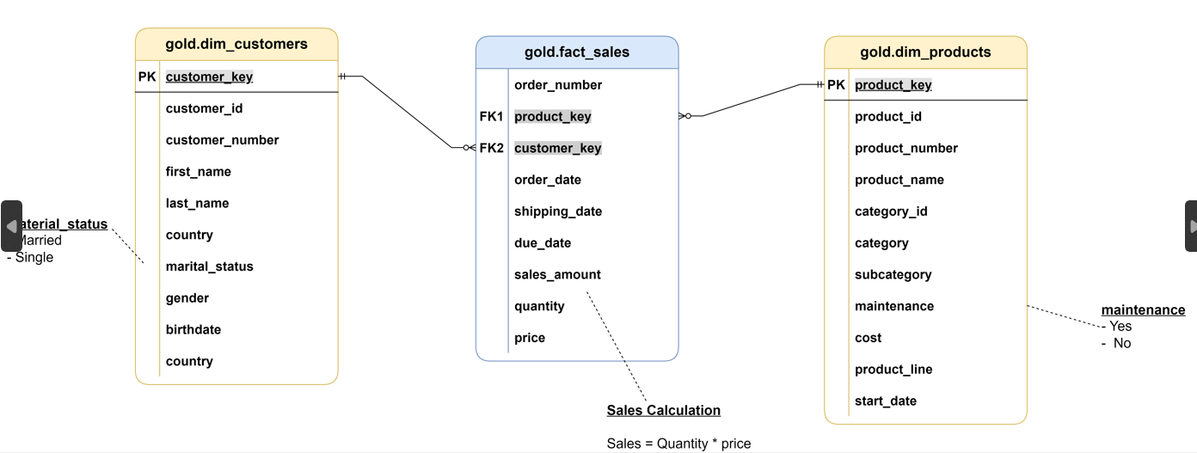

Power BI Project

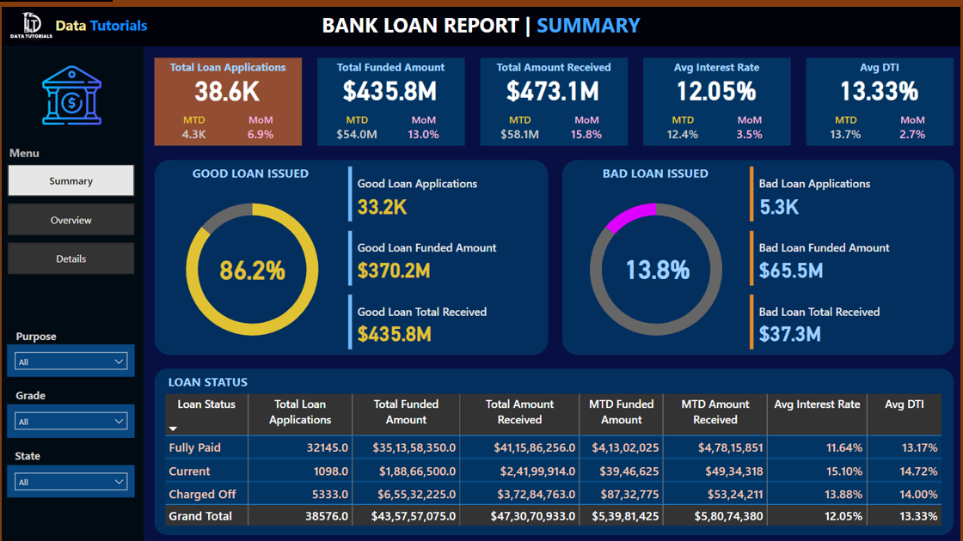

Project Objective
The primary objective of this project is to analyze the bank’s loan portfolio to understand the performance of good loans versus bad loans, assess overall lending health, and support data-driven decision-making.
Specifically, this project aims to:
- Evaluate loan portfolio quality by measuring the proportion of good loans and bad loans based on application count, funded amount, and amount received.
- Monitor key lending KPIs such as Total Loan Applications, Total Funded Amount, Total Amount Received, Average Interest Rate, and Average Debt-to-Income (DTI).
- Track loan performance trends across time (monthly), geography (state-wise), borrower characteristics (employment length, home ownership), and loan attributes (purpose, term, grade).
- Identify risk patterns associated with bad loans to minimize defaults and financial losses.
- Provide an interactive reporting solution that enables stakeholders to drill down from high-level summaries to detailed loan-level data for better monitoring and strategic planning.

📊 Key Insights Observed from the Dashboard
- Good Loans dominate the portfolio
  - ~86.2% of loans are classified as good loans
  - Bad loans account for ~13.8%, which still represents a significant risk exposure
- Bad loans contribute lower collections compared to funded amounts, impacting profitability.
- Debt Consolidation is the most common loan purpose, contributing the highest volume of applications.
- Renters and mortgage holders form a large share of borrowers.
- Higher interest rates and DTI are more prominent in charged-off (bad) loans.
- Loan applications show a steady upward trend over months, indicating growing demand.

✅ Recommendations
1️⃣ Strengthen Credit Risk Assessment
- Apply stricter credit checks for borrowers with:
  - High DTI ratios
  - Lower loan grades and sub-grades
  - Short employment length
- Introduce risk-based approval rules to reduce future bad loans.

2️⃣ Optimize Interest Rate Strategy
- Since bad loans have higher average interest rates, reassess whether higher rates are:
  - Compensating adequately for risk, or
  - Increasing default probability
- Consider balanced pricing models that attract reliable borrowers while controlling risk.

3️⃣ Focus on High-Performing Loan Segments
- Prioritize lending to:
  - Borrowers with longer employment tenure
  - Better loan grades (A & B)
  - Loan purposes with lower default rates
- Expand offerings in these segments to improve portfolio stability.

4️⃣ Improve Monitoring of Bad Loan Segments
- Closely track loans marked as Charged Off using:
  - Early warning indicators (missed installments, rising DTI)
- Implement early intervention strategies such as restructuring or reminders to reduce losses.

5️⃣ Geographic & Purpose-Based Strategy
- Use state-wise insights to:
  - Identify high-risk regions
  - Adjust lending limits or approval criteria regionally
- Re-evaluate high-volume purposes like Debt Consolidation, as they may carry elevated risk.

6️⃣ Enhance Collection & Recovery Processes
- Since the total amount received from bad loans is significantly lower, strengthen:
  - Collection strategies
  - Follow-up mechanisms
  - Recovery policies for delinquent loans

7️⃣ Use Dashboard for Continuous Decision-Making
- The Power BI dashboard should be used as a live monitoring tool to:
  - Track month-to-date (MTD) performance
  - Compare good vs bad loan trends
  - Support management and policy decisions in real time

🎯 Final Outcome
By implementing these recommendations, the bank can:
- Reduce bad loan ratios
- Improve profitability and cash recovery
- Strengthen risk management
- Make faster, data-driven lending decisions

Conclusion
- This Bank Loan Analysis project successfully provides a comprehensive view of the bank’s lending performance, with a strong focus on good loans vs bad loans.
- The analysis shows that good loans form the majority of the portfolio (≈86%), indicating overall portfolio stability, while bad loans (≈14%) represent a critical risk area that requires continuous monitoring.
- Key KPIs such as Total Loan Applications, Funded Amount, Amount Received, Average Interest Rate, and DTI help assess both profitability and credit risk.
- Trend, geographic, and borrower-level analysis highlights patterns influencing loan performance, enabling identification of high-risk segments.
- The interactive Power BI dashboards allow stakeholders to drill down from summary insights to detailed loan records, supporting transparent and data-driven decisions.
- Overall, this project demonstrates how data analytics can enhance credit risk management, optimize lending strategies, and improve financial health of the bank.

